13th Bn The King’s (Liverpool) Regiment (The King’s)

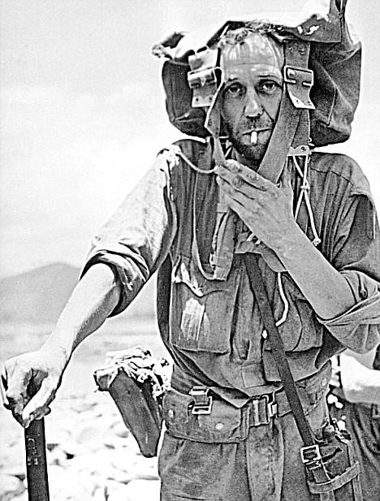
Peter F. Snell Beer at 'Piccadilly', Burma April 1943.

“ He (Wingate) was given a British Battalion which, on the surface, could hardly have been worse suited for the task he had in mind. This was the 13th King’s (Liverpool). They had been on coastal defense duties in England before being drafted out to serve as garrisons in India. They were city-bred men, not only from Liverpool but from Glasgow and Manchester; most of them were married and many were over 30.” [1]

Below you will find the required items needed for this event when representing ‘The King’s’. All items required unless marked optional, preferred items are considered the best option for this event. Unlike other immersion events, this will test your gears’ endurance and construction. So quality items should be purchased when possible.

*** ALL IMPRESSION RANKS WILL BE OF PRIVATE OR RIFLEMAN****
For information on portraying an Officer or Non-Commissioned Officer (NCO) please contact us at 12kpevent@gmail.com for the application.

Grooming and Personal Appearance

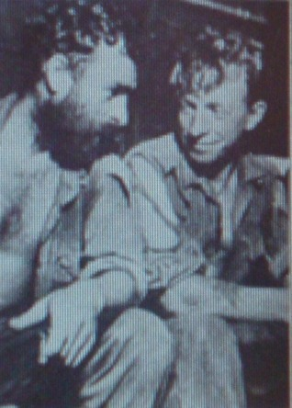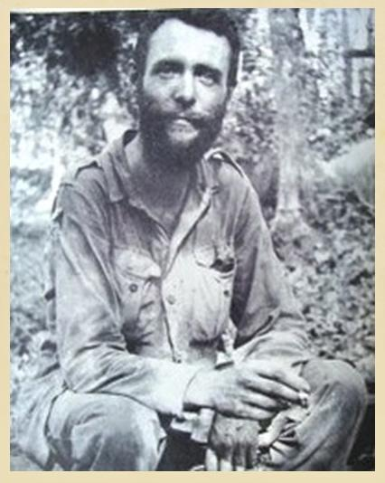
“We were told to throw away any unnecessary articles to reduce the load we had to carry. My first error of judgement was discarding one half of my mess tin. It caused me great inconvenience during the next few months. I threw away all of my shaving kit and eventually sported quite a beard, a Victorian style 'mutton-chop' affair.” Lance Corporal George Bell

- Your overall appearance should be of someone living in Burma off the land hiding like wildlife for 3 months.
- Facial hair should be the norm for this event. Beards must be no longer than 3 months of growth and un-kept, with absolutely no goatees or shaped/ groomed beards. (See original photos)
- Non-period tattoos must be covered. Tattoos on the neck and face are unacceptable.
- Wedding rings are acceptable as long as they look period. Period ID bracelets or medical bracelets are allowed. No other jewelry is permitted.
- If you wear spectacles, they must be period or contacts must be worn. Regulation British spectacles have small circular metal frames and metal hooked sidearms. Sunglasses or shaded lenses are not permitted, period or not.
- No modern watches are allowed. Period wristwatches and pocket watches are allowed. If in doubt, check with the event coordinators.

Uniform
Khaki Drill and Aertex (Tropical, Cellular).
*** NO P43 JG uniforms during the march.***
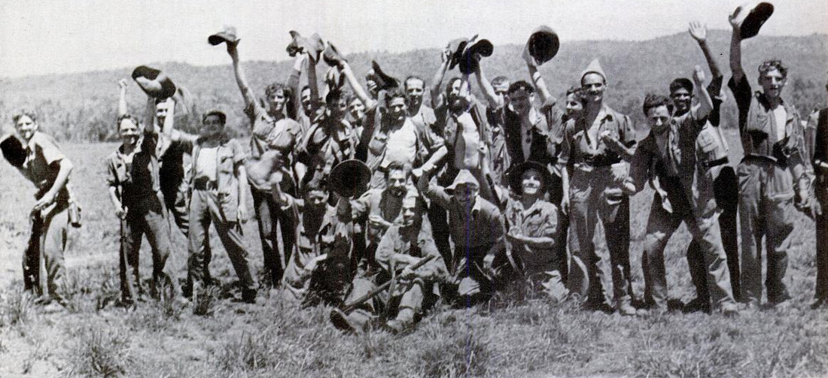
Members of Column 7 and 8 Dispersal Group 28 April 1943 at ‘Piccadilly’

Your overall goal is to look worn and tired. We will not require you to rip up your uniform for this event as supply drops of uniforms were received by different elements during late March and into April. Though some of the original photographs show what looks to be green-dyed uniform items. Through accounts, they are just dirty uniforms, and at this time nothing has surfaced to indicate they received green uniforms before or during the operation.

Lt. MacHorton 2nd Column - "Every day and all the time we sweated so that our clothing and equipment was black and stinking and becoming rotten with it, half the time our eyes were blinded with sweat. Every day our muscles ached and our bones almost groaned aloud in the agony of our exertions. Every day our filthy and sodden clothing became more and more torn, ripped and ragged until most of us looked like walking scarecrows."

Lt. Stewart-Jones 5th Column “Our clothing was in rags and a few men were without any footwear. Our journey took us as high as 5000 feet and into very cold conditions, followed almost immediately by plunging down once more into the steaming hot jungle valley."

Lance Corporal George Bell “We had also become lousy and our clothes were disgusting”

Eric Allen “My original khaki slacks were reduced to tattered shorts, and my legs were covered in angry looking jungle sores. These formed after the slightest scratch."

Sergeant Hayes “I looked around the little group of battle-stained and weary men. Above the stench of their sweat-sodden clothing, by now little more than rags, the air was rancid with the sweet-sour smell of dried blood and suppurating sores.”

Dalbahadur Pun Column 1 “Our clothes were in rags, footwear was worn out and our feet were in a bad state. Our hair hung down our shoulders.”
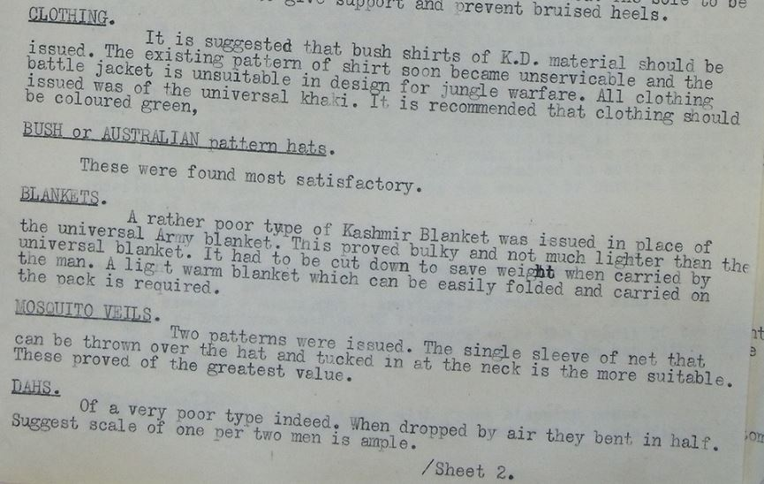

Headwear - Should be properly constructed British, Australian or Indian pattern slouch/bush hat.

- Bush/Slouch Hat- with or without edging or snap.

These appear to come in three variations- British made, Australian made (whether military or private purchase), and Gurkha specific. Many accounts speak of “Aussie style” hats or something similar, possibly due to the slouch hat being associated with Australian troops, and may refer to British made hats.

The Gurkha hats are distinct, and issued specifically to those units. Due to the scale of wartime manufacture, slight variations exist in all these items.

The typical British WWII slouch is brown wool felt with a brim around 3 ½”. It has a leather sweatband with the manufacturer’s stamp and broad arrow inside, no edging on the brim, and a
snap to hold the left side up. They appear to have been issued with a piece of white or off white cloth tape around the crown, with many units adding a pagree (a folded band of cloth) as well as some level of insignia. The hats came with a leather chinstrap, similar to the one on the SD cap, which passes through a gap where the sweatband is not sewn down before mounting to split pins inside the hat under the hatband.

They have some number of air vents (2-5) on the side of
the crown above the band, generally with metal grommets painted brown. The snaps are small, ¼” and dulled.

Australian hats look very similar, but may have a piece of tan grosgrain ribbon edging the brim, and may be held up by either a snap or a sewn-on metal hook. The hooks were used in WWI, partially replaced by snaps during WWII, and then brought back postwar for the dress
slouch.

During the First World War they were worn with a band of khaki wool around the crown,replaced in 1930 by a folded cotton pagree. The Australian War Department mark is a broad arrow with a capital “D” on either side.

The Gurkha hats, known to them as a Terai hat, was made of double thickness, which made them stay straight during long term exposure to adverse weather. 77 Brigade’s report from the campaign specifically says that they were harder to camouflage due to the outline not
breaking up the way the British and Aussie hats did when the brims drooped.

Terais were typically worn with a pagree and chinstrap.

As worn on the actual operation, most of the British/ Australian hats seem to have drooping brims from the constant rain. Chinstraps and pagrees appear, but are by no means universal, and many hats have nothing worn around the crown.

Several photos of Gen. Wavell’s inspection in February show troops wearing helmet nets over bush hats, but no photos of the actual
expedition show this.

No insignia commonly appears on hats during OPERATION LONGCLOTH. Some men may have worn a cap badge, but this appears to have been an
individual addition.

The crowns were typically shaped to individual preference, either with a
crease down the middle or “porkpie” style with an edge going all the way around the top.

For reenacting, the best option (at the moment this is being prepared) is to find an Australian hat and do any required conversion to achieve the desired look. These vary by manufacturer and while they typically have edging to the brim, they may or may not have snaps,
chinstraps, pagrees, or other military features.

Currently no one reproduces the British made hats. Australian hats are available, although they can be expensive. There is discussion about reproducing the Gurkha style hats.

Top -
- Shirt - Tropical, Cellular (Aertex) collared shirt in khaki only
https://www.whatpriceglory.com/products/1214-uk-wwii-aertex-desert-shirts/
- Jumper/Pullover (sweater) - British or Indian pattern original or reproduction - optional but recommended for the cool nights.
https://www.oldtimedesigncompany.co.uk/product-page/pullover
- Bush Shirt/Jacket Indian pattern- Should be Aertex material with pleated upper pockets with Scalloped or Straight edge flaps. Bottom pockets should be patched un-pleated pockets with straight edge flaps in Khaki color only. Optional with modification https://www.whatpriceglory.com/products/1228-uk-wwii-pattern-aertex-khaki-drill-bush-shirt-or-jacket/

Trousers -
- British or Indian early pattern (P41) KD trousers in Khaki - most common appearance
https://www.whatpriceglory.com/products/1254-british-early-wwii-pattern-khaki-drill-trousers/
- Cut down trousers into shorts - These can be cut down from the above trousers - Optional but the most common shorts seen
- ***Indian pattern Khaki BD pants (as seen in photos) - limited numbers and should be the exception
https://www.whatpriceglory.com/products/1926-uk-mid-war-tropical-bd-trousers/

Underwear - Optional
- Tropical lightweight boxers
https://www.whatpriceglory.com/products/8598-uk-cotton-cellular-weave-summer-underwear-shorts/
- Blue Sports shorts
https://www.whatpriceglory.com/products/4725-british-wwii-blue-pt-shorts/
- Nondescript boxers in white or green

Footwear - Note- Civilian hiking socks that outwardly resemble an issue sock above the top of the boot are authorized. Minimum 4 pairs required.

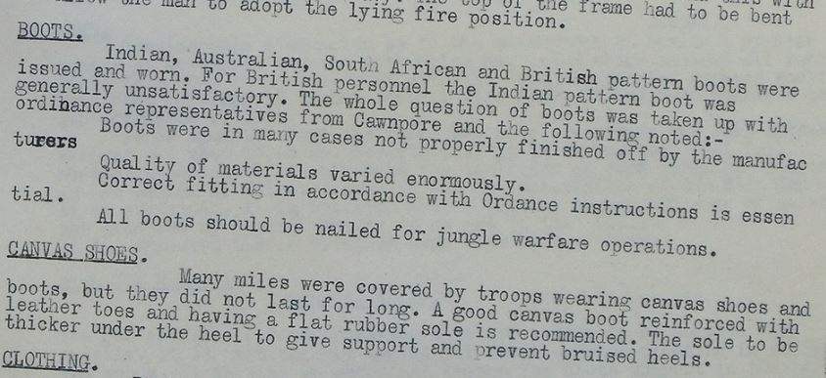

- British cap toe black leather with correct square-cut black leather laces we recommend at minimum a 6-month break-in period for new boots to prepare for this event. You will be walking typically 8-14 miles a day through mountainous terrain.
SM Wholesale
WPG
- Indian Pattern boot
- Australian Pattern boot
- South African Pattern boot
- Plimsoll sports shoes - required
https://www.whatpriceglory.com/products/4963-uk-wwii-style-plimsolls-reproduction/
- Wool Issue shocks of gray or white wool (see the note above)
https://www.whatpriceglory.com/products/7573-wool-boot-socks/

https://www.whatpriceglory.com/products/2149-us-army-usmc-and-british-army-gray-wool-blend-socks/

Equipment
***All webbing will be original or quality reproduction Pattern 37 with brass hardware.***
***No blackened hardware will be authorized***
Blanco must be scrubbed or in No 64 or 103 Blanco.
Blanco should be in a worn state of 3 months of use without re-application.

Basic webbing set - Due to the time frame portrayed we are leaving it up to the individual what they decide to wear. There will be minimum requirements and full load options. We will list the complete load at the start of the operation HERE for those that want to challenge themselves.

- P37 webbing belt- Required
- P37 Basic pouches (Mk I or II preferred) or Cartridge carriers - one or the other or a mix of both
- P37 Left and Right Braces- optional
- P37 Water bottle carrier
- Water bottle green/brown or blue enameled with correct wool felt cover in khaki green or khaki gray - Required (No post-war RAF covers)
- Haversack with or without L straps (If not using L straps 1-2 braces required)
- P08 Large pack - Optional

Additional Items -

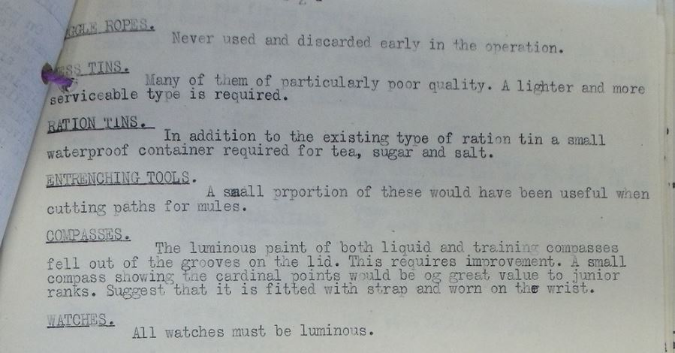

- ‘Housewife’ sewing kit correct reproduction-
- Groundsheet MKVI or VII Tan/khaki British wartime pattern. NO GREEN Original or WPG.
- Blanket cashmere or wool - grey, grey/brown, white. Optional but highly encouraged. Accounts exist of maintaining blankets during the withdrawal with some dispersal groups
https://www.whatpriceglory.com/products/8239-original-unissued-gray-wool-blanket/
- Mess tin both parts or just one - you will need this to prepare rations in
- Cup pint - in white with blue rim, or brown
- Spoon - required
- Fork and Knife - optional
- Jackknife - original or post-war, with lanyard - highly encouraged
- Original or reproduction cap comforter from WPG
- Machete (Dha), original or reproduction wartime British or Indian pattern with leather sheath only (chose a Dha or Kukri or both)
https://www.amazon.com/British-Joseph-Sheffield-ENDURE-Machete/dp/B01BE6HRFY?fbclid=IwAR0DyFuTkOIogd3tRNERL7_wdFA2m59bbEYHwN91XpZGMZF6N8gxz4Hh0W8
- Kukri - correct Nepalese pattern
- Everest pack frame - Optional - the bergan reproduction pack frames can be used. You must replace the ruck itself with a 37 pattern haversack or 08 pattern large pack or both.

Weapons

- No. 1 MKIII/MKIII* Enfield rifle. No - No. 4 Enfields
- Bren gun MKI or MKII
- Thompson 1928A1
- Pistol - officers and support roles- weebly, browning high power etc.

Notes

- Allen, L. (1986), Burma: The Longest War 1941-45, 121

